FOR NOVEMBER…
@0:32
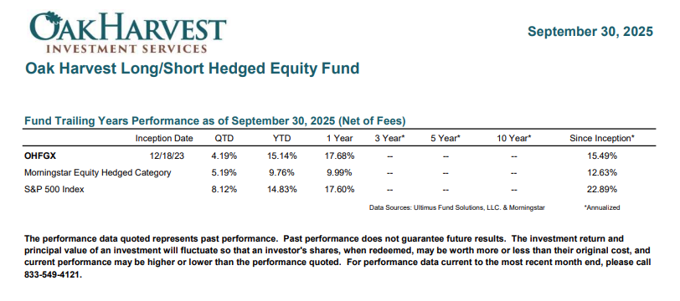

Ending Disclosures

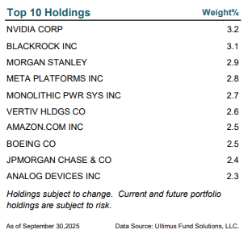

Mentioned Holdings
Flowserve Corporation (FLS) 1.164%
Medtronic plc (MDT) 0.573%
Domino's Pizza, Inc. (DPZ) 0.456%
IonQ, Inc. (IONQ) 2.145%
Spotify Technology S.A. (SPOT) (0.326%)
Coherent Corp. (COHR) 2.233%
Fabrinet (FN) 2.248%
Celestica Inc. (CLS) 2.247%
Wynn Resorts, Limited (WYNN) 2.449%
Teva Pharmaceutical Industries Limited (TEVA) 2.340%

As of November 30, 2025
Data Source: Ultimus Fund Solutions, LLC.

