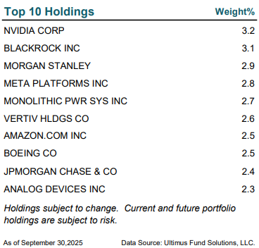

Mentioned Holdings
Eaton Corporation plc (ETN) 2.920%
Comfort Systems USA, Inc. (FIX) 2.111%
Teva Pharmaceutical Industries Limited (TEVA) 2.239%
Snowflake Inc. (SNOW) 2.254%
Twilio Inc. (TWLO) 2.212%
Cameco Corporation (CCJ) 2.235%

As of October 31, 2025
Data Source: Ultimus Fund Solutions, LLC.

