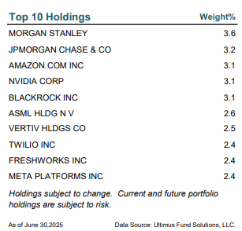

Mentioned Holdings
Broadcom Inc. (AVGO) 1.907%
Oracle Corporation (ORCL) 0.975%
Robinhood Markets, Inc. (HOOD) 1.5726%
Ambarella, Inc. (AMBA) 0.477%
Electronic Arts Inc. (EA) 0.000%
StubHub Holdings, Inc. (STUB) 0.000%
Live Nation Entertainment, Inc. (LYV) (0.945%)
Ciena Corporation (CIEN) 1.263%
Vertiv Holdings Co (VRT) 2.616%
Alibaba Group Holding Limited (BABA) 0.827%
Wingstop Inc. (WING) 1.018%

As of September 30, 2025
Data Source: Ultimus Fund Solutions, LLC.

